Geometry: Unit 12, Lesson 2

- Point $R$ is on line segment $XY$. Given $XR=7$ and $XY=22$, determine the length of $\overline{RY}$.

$$15$$

- Point $P$ is on line segment $ST$. Given $SP=9$ and $PT=8$, determine the length of $\overline{ST}$.

$$17$$

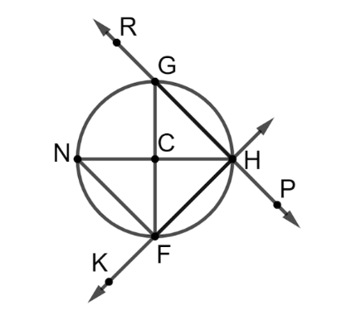
- Circle $C$ is shown with points $G, H, F,$ and $N$ on the circle and points $R,P,$and $K$ outside the circle. Give an example of a secant of circle $C$?

$$\overset{⃡}{KH}$$

